Tasks
Task 1: Customer Orders Write a query to display:
• customer_name • order_id • amount Include only customers who placed orders.
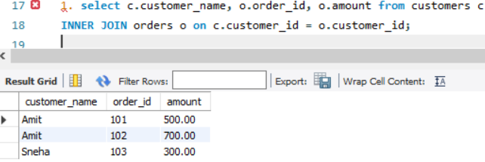
Task 2: All Customers Write a query to display: • all customers • their order_id (if any) Customers without orders should still appear.
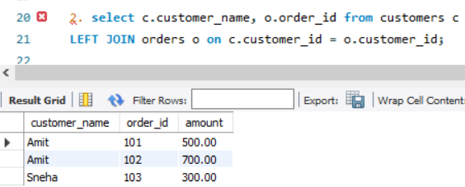
Task 3: Invalid Orders Write a query to find: • orders that do NOT have a matching customer
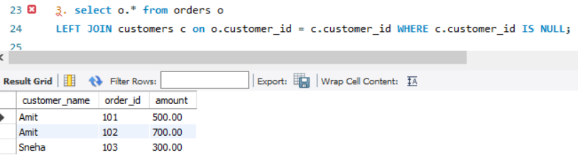
Task 4: Order Payment Status Write a query to display: • customer_name • order_id • payment_status Include all orders, even if payment is missing.
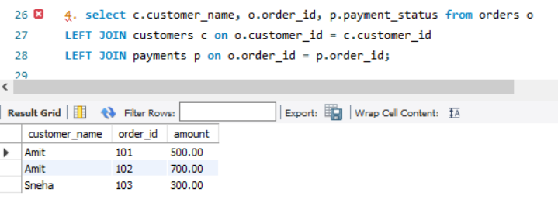

Task 5: Customers Without Orders Find customers who have never placed an order.
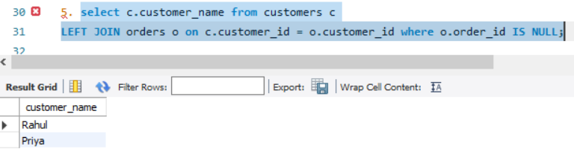
Task 6: Orders Without Payment Find all orders that do not have a payment record.
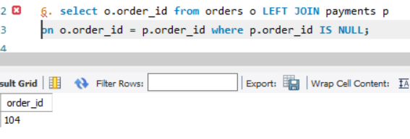
Task 7: Total Spending Write a query to calculate: • total amount spent by each customer
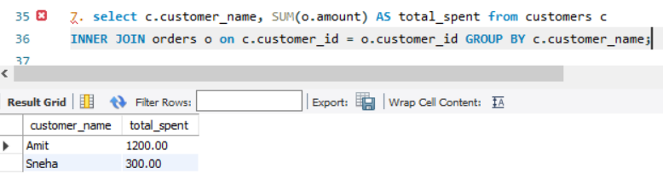
Task 8: Fully Paid Customers Find customers whose all orders are marked as 'Completed'.
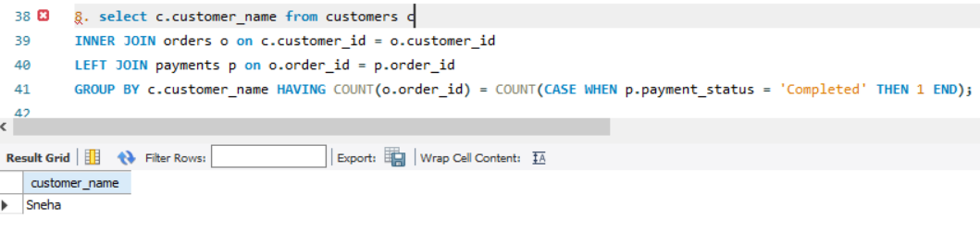
Task 9: Highest Order Per Customer Display: • customer_name • highest order amount
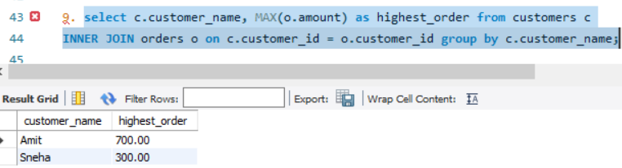

Task 10: Top Customers Find top 2 customers based on total spending
